Cardiac-cause Mortality

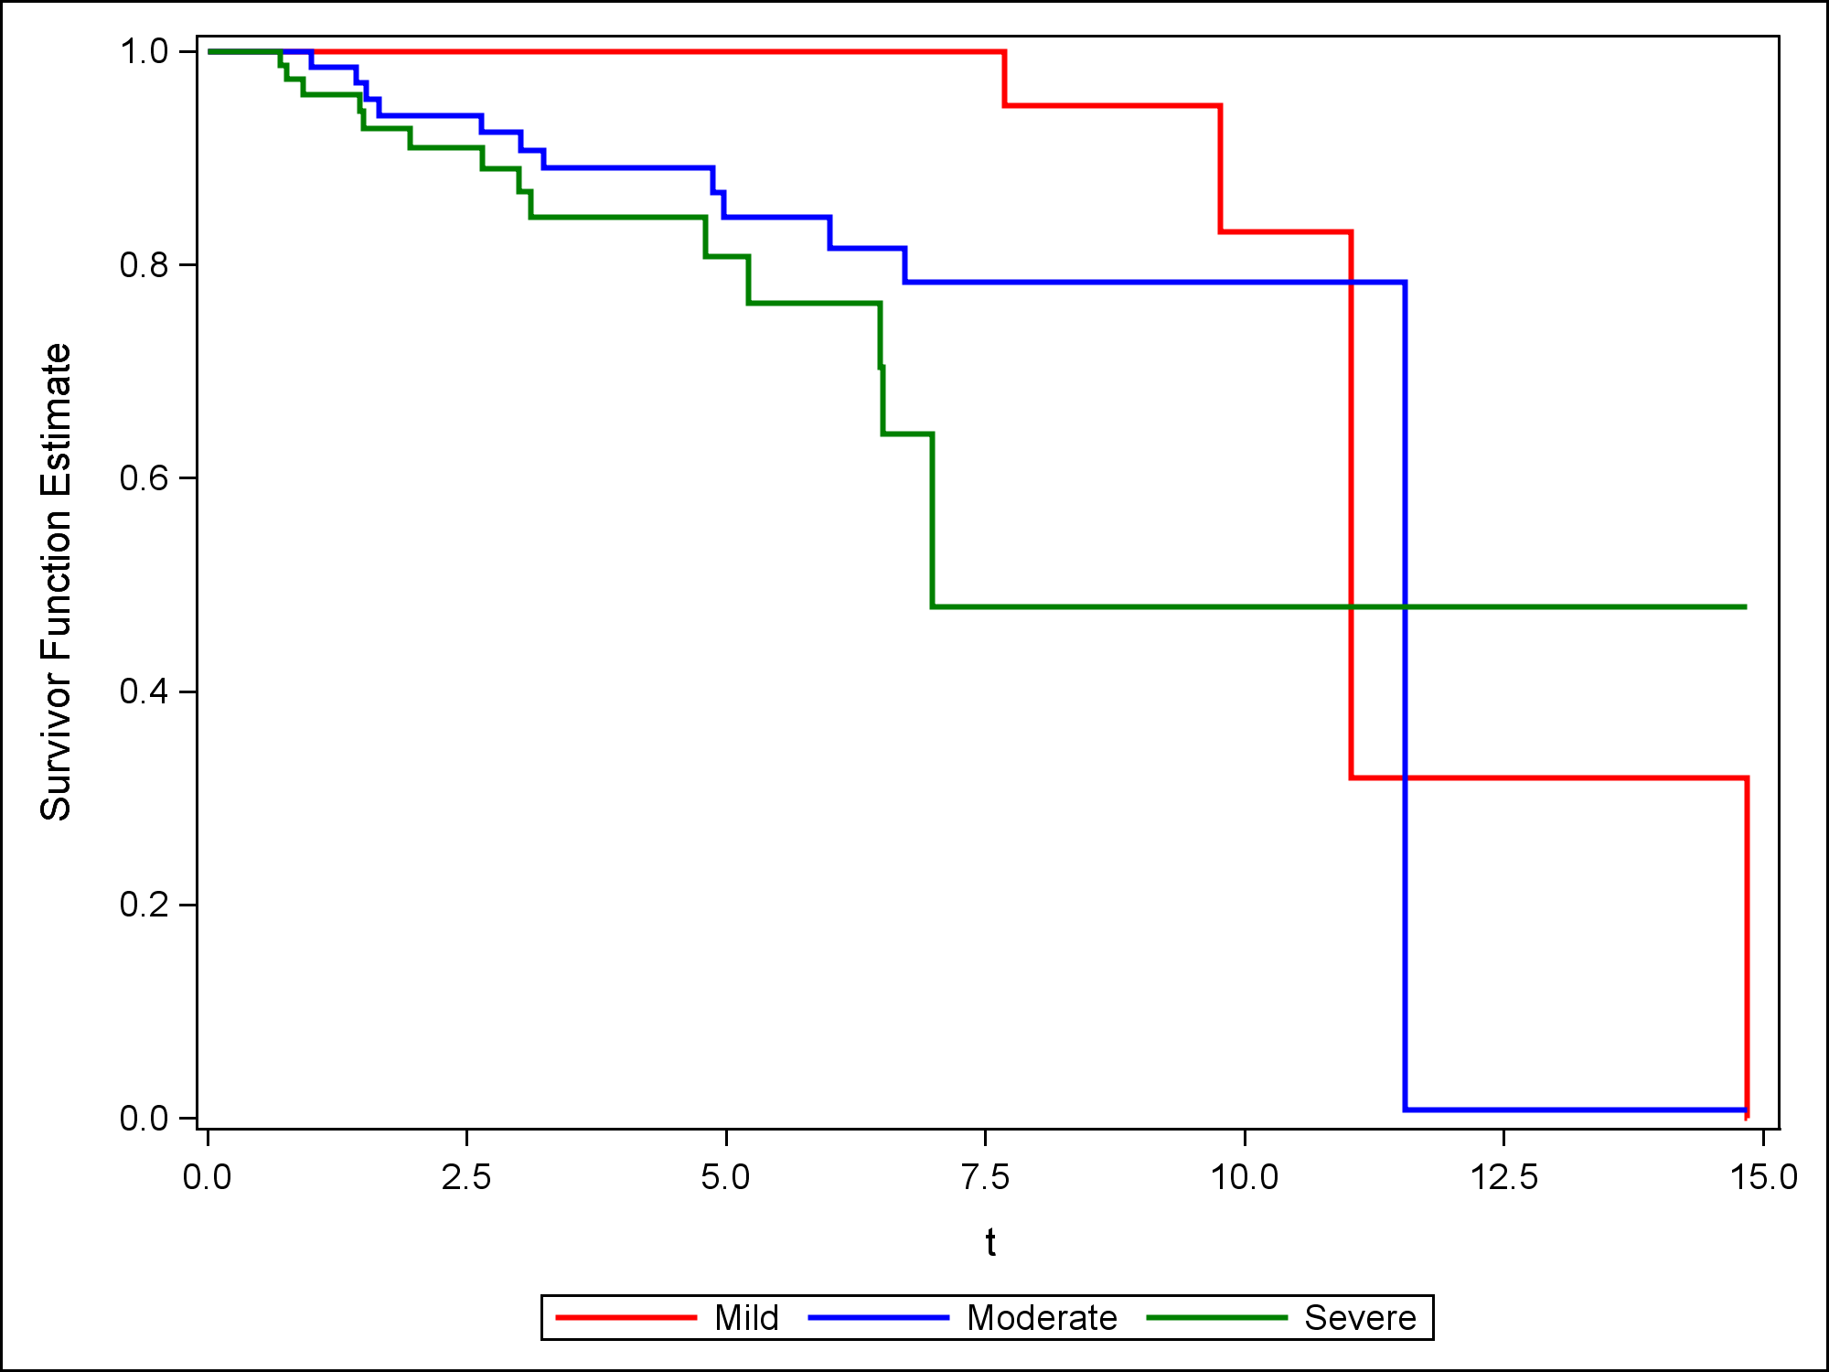

Figure 5: Cox adjusted survival curves for cardiac mortality evaluating the effect of PG on survival in the presence of other covariates (age and sex. Survival was more favorable for both mild (P <0.0001) and moderate groups (P = 0.0002) compared to the severe group.